Russian Depository System: modern theory, practice and trends.

Adamova Karine

Ph.D.(Economics)

Chair of Securities and Financial Engineering

Finance Academy, Moscow

E-mail: adamova_karina@rbcmail.ru

Contents:

Regulation basis and the structure of the Russian depository system.

Custody services and depository operations of the banks

The last trends on this market

The theme of this report is Russian Depository System: modern theory, practice and trends.
During the report you will know about the regulation basis and the structure of the Russian depository system, about custody services and depository operations of the banks and the last trends on this market.
So let’s begin with the regulation basis and the structure of the Russian Depository System.
There are next key elements of Russian state regulation of the depository system:
- Civil Code;
- Securities market Act;
- Legal acts of the main state regulators of the securities market.
The main regulators on the Depository Services Market in Russia are:
- Ministry of Finance of The Russian Federation;
- Federal Financial Markets Service (previously it was Federal commission for securities market);
- Central Bank of Russia;
- PARTAD (The Professional Association of Registrars, Transfer Agents and Depositories).
Nowadays structure of the Russian Depository System is presented on the below scheme:

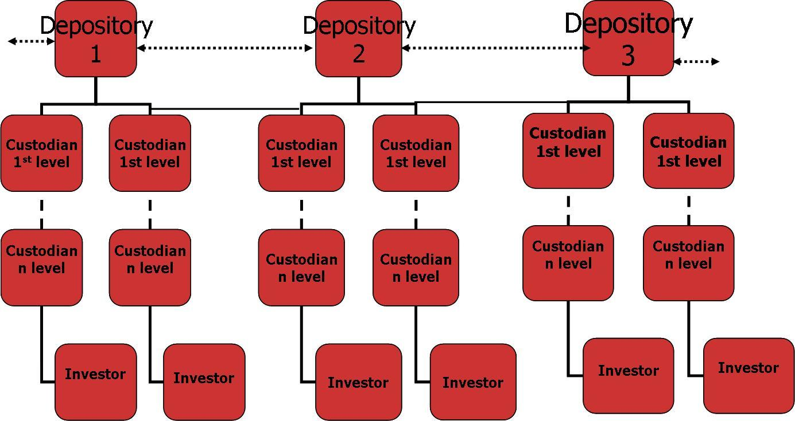

Some comments on the above scheme.
The Depositories 1,2,3 and so on ─ it’s a limited number of depositories which serve the trade deals with securities on the main stock-exchanges. Such as the National Depository Center, the Depository Clearing Company and etc.
The first and the lower levels are represented by the financial institutes (banks, investment companies or just custodians) who received special depository license from the Federal Financial Markets Service.
The Main Functions of the Depositories from the theoretical point of view are:
- Accounting and custody of securities;
- Securities settlements;
- Informational and administrative functions in case of securities operations.
But in the world practice the functions of such Depositories are:
- Accounting and custody of securities
- Securities settlements
- Paying dividends or other incomes on securities
- Monitoring the Issuers corporate actions
- Calculating the value of client’s securities portfolio (optional)
- Tax management (optional)
- Informational services
- Banking services
- Crediting with securities (optional)
- Clearing (optional)
In the Russian practice such Depositories always execute lees number of functions and they are the following:
- Accounting and custody of securities
- Securities settlements
- Paying dividends or other incomes on securities
- Monitoring the Issuers corporate actions
- Informational services
- Clearing (optional)
As you see, in Russian practice the number of services provided to depository’s clients is less then in the world practice. First of all it’s caused by conservative securities market legislation.

So, as it was mentioned above, the first and lower levels of custodians are represented by different financial units such as banks, investment companies and just custodians, which operate in accordance with special licenses issued by the Federal Financial Markets Service.
From this number of enterprises the most universal services may be provided by commercial banks and in Russian economics it’s mostly so, because Russian securities market was started by commercial banks.
So let’s give some words about the custody services and depository operations of the banks.
Usually banks provide basic custody services and accompanying custody services:
- Basic services:
  - Holding the certificates of the documentary securities and accounting securities rights;
  - Intermediary services in paying all kinds of securities incomes;
  - Informing clients in case of Issuers corporate actions;
  - Global corporate operations in case of Issuers corporate actions;
  - Securities settlements;
    - Accompanying services:
      - Holding clients monetary accounts intended for settlements under the securities operations and receiving dividends and interests paid on securities;
      - Checking the securities certificates for authenticity, their collection and transportation;
      - Acting in the name of the client on the annual shareholders meetings;
      - Informational services on the securities market;
      - Monitoring the Issuers corporate actions, informing and supporting clients;
      - Banking services;
      - Calculating the value of client’s securities portfolio;
      - Other services based on securities operations.
Above mentioned services are always provided through executing depository operations.
On the below scheme you can see the classification of the depository operations of the bank.
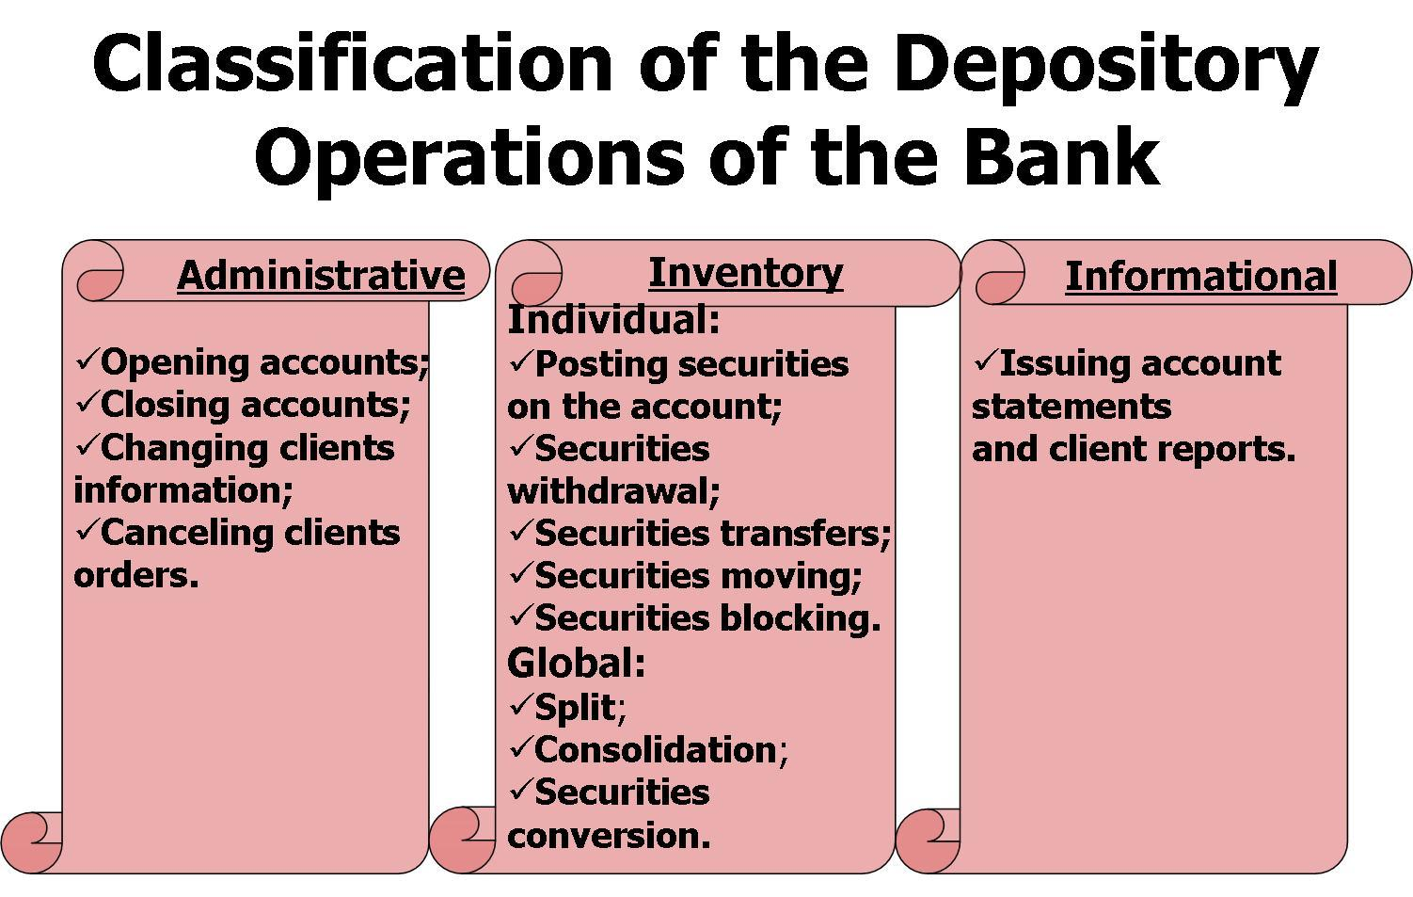
All those custody services and depository operations are always regulated by state legislation and bank’s depository rules.
The structure of bank’s depository rules you can see on the scheme below.
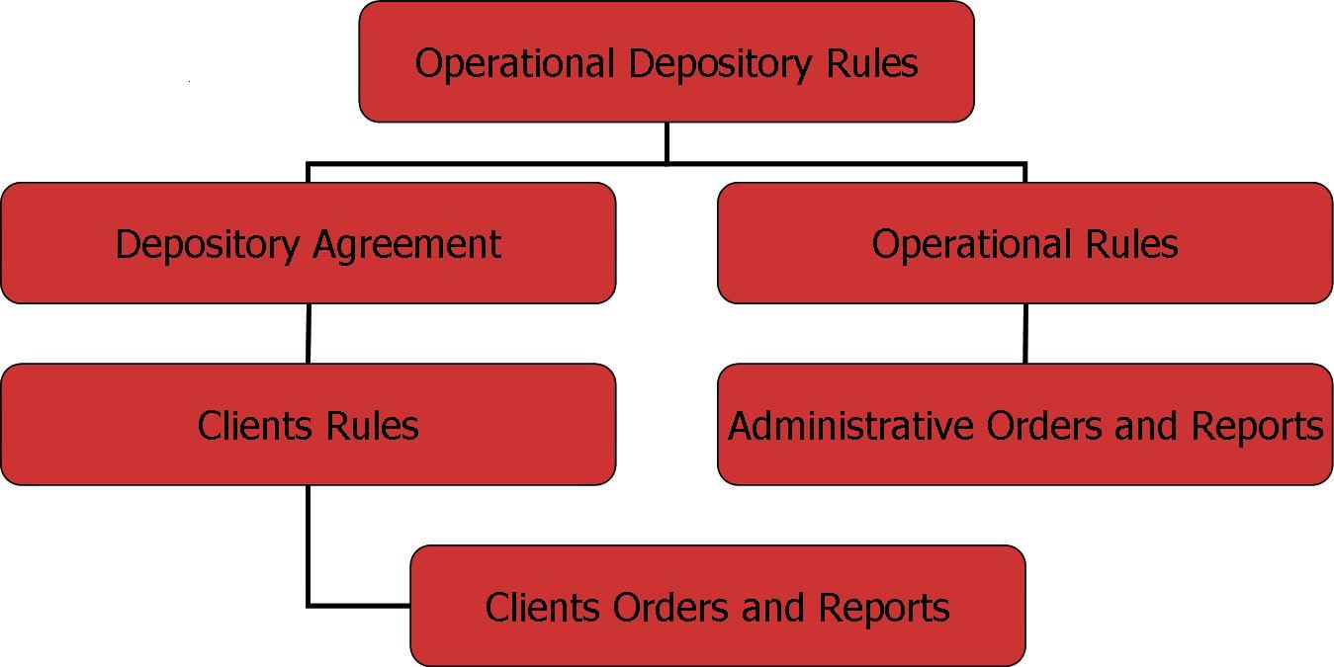

The Depository Agreement and the Client’s Rules, Orders and Reports are public documents and they are controlled by state regulatory bodies. The Operational Rules and the Administrative Orders and Reports are internal documents.
Bank’s depository technologies are dynamically developed in accordance with market needs and trends, especially in cases of international standards and international integration processes. But off cause still there some problems in this area.
As per statistics there are top 8 safest custodian banks as at 31.12.2004:
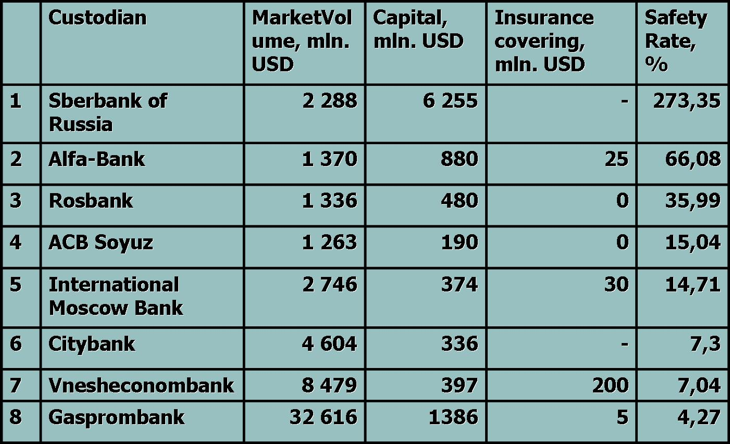
The Safety Rate for custodian banks was calculated as the sum of capital and insurance covering divided by market volume of accounted securities and was translated into percentage valuation.

And the third part of my report concerns the last trends on the market.
We will talk about:
- Current situation on the market;
- Central Depository of Russia;
- Securities accounts of Global Custodians and Settlement Organizations holding with Russian Custodians;
- Integration processes between the depository systems of the post-soviet countries.
The market statistics is that:
    - Total securities market capitalization as at 31.12.2004 was 212 200 mln. USD;
    - The number of depositories in Russia as at 31.12.2004 was more than 700;
    - 80% of the market volume of securities was served by 10 largest depositories (see below table).

Top 10 Depositories which served the largest volume of securities up to 31.12.2004
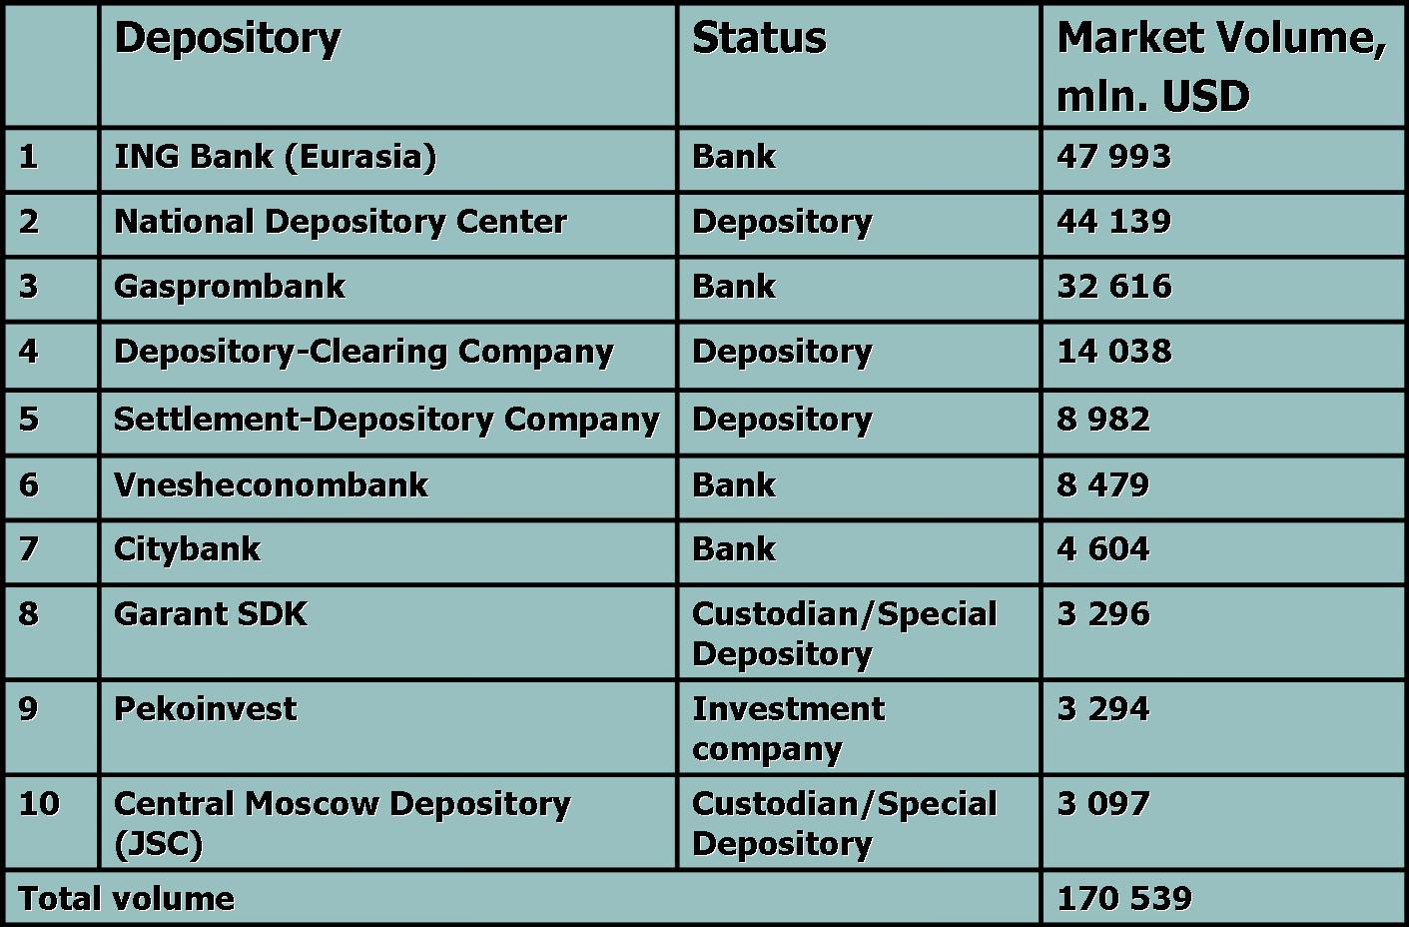
We can indicate three main problems of Russian Depository System.
First of all, wide diversity of depository technologies on the securities market without any unifications is the main reason of non-effective corresponding relations.
Then we indicated the insufficient structure of Depository System: unlimited number of levels of corresponding depositories relationships is the main reason in troubles of identification of the securities owner/real investor.
The last one is that securities regulation needs significant changes in case of market demand and especially in case of integration in international financial market.

Nowadays Russian depository institutes and state regulatory bodies hard work together to solve these problems. They initiated a new model of the structure of the Russian depository system (see below scheme).
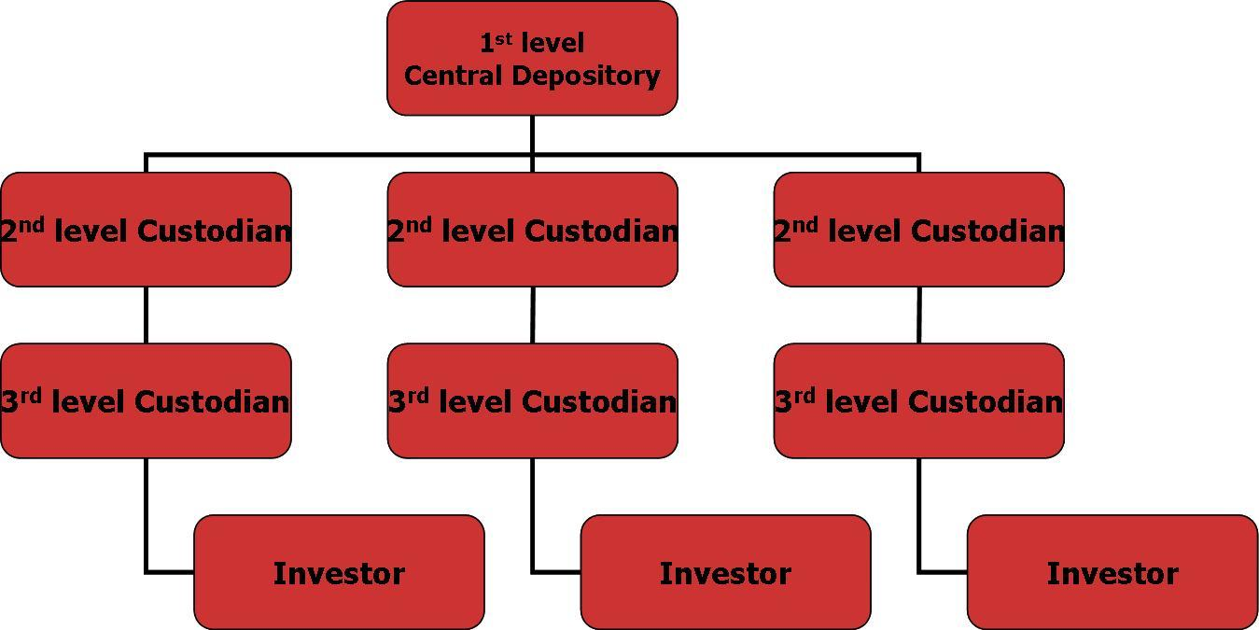

Some words about the securities accounts of global custodians and global settlement organizations such as Euroclear and Clearstream.
Under Russian state legislation mentioned enterprises are not able to hold custody correspondent accounts with Russian depositories and custodians because such operations need special depository license issued by Federal Financial Market Service.
Today all those accounts which are used for purposes of custody corresponding operations between Russian and foreign depositories are opened as owner’s (or investor’s) accounts.
This problem is one of more key points of insufficient Russian legislation which brake the integration of Russian securities market and Russian enterprises with global financial markets.
The integration processes between the Depository Systems of post-soviet countries began with the establishment of the International Association of Exchanges of CIS Countries in 2000. Then in 2001 in Toshkent took place the International Congress “Integration of Depositories Systems – is the basis of the effective cooperation on the international securities market”. It became an annual meeting. The last one took place in 2004 in Moscow. At the end of it the members decided to establish the Association of Eurasia Central Depositories. On the 22nd December 2004 the First Organizational Conference of the Association of Eurasia Central Depositories was successfully start.
The Association of Eurasia Central Depositories – is a professional organization which activity is concentrated on the evolution of the national financial markets, on the unification of the legal regulation and the principles of structuring national depositories systems.
The Members of the Association are the depository institutes from Republic Uzbekistan, Russian Federation, Ukraine, Moldova, Azerbaijan, Republic Belarus, Georgia, Kazakhstan, Republic Kyrgyzstan.
As the result of such integration processes we see the effective operating securities market with high liquidity.

Thank you a lot for your attention to Russian securities market and depository system.

